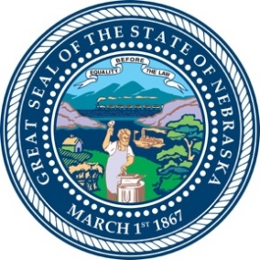
Nebraska Commission on African American Affairs
Notice of Public Meeting
Pursuant to Nebraska Revised Statutes Section 84-1411, notice is hereby given to members of the Nebraska Commission on African American Affairs Commission and the general public that the Commission will hold a special meeting, open to the public at 5:00pm on Tuesday, February 6, 2024. The meeting will be held at the Omaha State Office Building, 131 Farnam St, Omaha NE, 1st Floor Conference Center, Room #105, The “Hall Room”. The meeting will be recorded for later public viewing and access.‬ Pursuant to Neb. Rev. Stat. Section 84-1410(1), the Commission may vote to go into Executive Session, which will not be open to the public, for legal advice or sensitive personnel discussions concerning any item on the agenda.
Agenda
- Call to order
- Public Meeting Posting Announcement
- Roll Call
- Executive Committee openings
- Motion for Executive Session
- Administrative issues raised by State Offices
- Other business
- Reopen of public meeting
- Record and vote on actions of Executive Session
- Comments from the Public
- Adjourn
Pursuant to Title II of the Americans with Disabilities Act (ADA) the Office of the Governor does not discriminate on the basis of disability regarding admission to public meetings. Persons with a disability may request a reasonable accommodation, such as a sign language interpreter, by contacting Toni Clarke (402)598-8664. Requests should be made early as possible to allow time to arrange for the accommodation.

